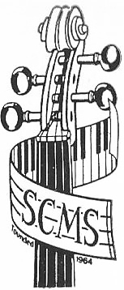
Stratford-upon-Avon Chamber Music Society
Registered Charity No. 508874
Season Ticket Application Form
I/We wish to join the Society for the 2023/2024 season and enclose £……………….. in payment
(Adults £100, Students £20).
I also enclose a donation of £…………………..

Title……………….……
Name (s)……………………………………………………………………………..
Address……………………………………………………………….……………………………………………………………………………………………………………
………………………………………………………………………………………………………………………………………………….…………………………..…………
……………………………………………………………………………………………

Post Code………………………………………………….………..

Email…………………………………………………………………..

Telephone…………………………………………………………..
Gift Aid Declaration
I would like Stratford-upon-Avon Chamber Music Society to reclaim tax on all my donations made on or after 6th April 2023 until further notice. I am a UK taxpayer and understand I must pay an amount of income or capital gains tax at least equal to the tax deducted from my donation.

Signature of donor…………………………………………….

Date…………………………………….

Please return this completed form with a cheque payable to Stratford-upon-Avon Chamber Music Society to the Secretary:
James Hazel, 1 Holly Orchard, Stratford-upon-Avon CV37 6RJ

It would be much appreciated if you included a stamped self-addressed envelope with your application. Thank you!

